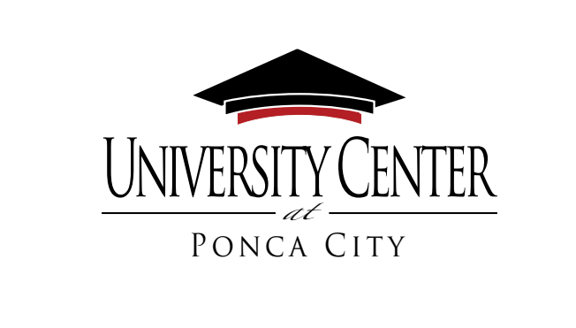

Expressive Speech Annual Report

December 31, 2023
Pursuant to 70 O.S. §2120, The University Center at Ponca City submits the following to demonstrate its course of action for compliance with the requirements of this statute.
Campus Expression Policy
Please find the full proposed policy and procedures link on The University Center at Ponca City Home Webpage, www.ucponcacity.com The proposed policy will be voted on by the Board on January 5, 2023.
Professional Development for Students and Employees
The University Center at Ponca City plans to communicate policy and expectations to students and employees through educational programming provided to the faculty, staff, and students, as well as publication of policies in their respective handbooks and on the university’s website. The University Center may also choose to communicate new policy and/or updates through electronic communication.
Copy of Professional Development Training Information Sheet
The following professional development information will be provided to the campus community via meetings with faculty, staff, and students. The information will also be located in the Student Services Office of the University Center.
The University Center at Ponca City Professional Development First Amendment, Expressive Speech, and 70 O.S. §2120
Part 1: State Law
- Passed in the 2019 Oklahoma Legislature, signed by the Governor, effective August 30, 2019. Available online.
- In brief, the law requires that, on Oklahoma public colleges and universities campuses, the campus community and the public may use unrestricted accessible outdoor space for noncommercial expressive activities because this space is now designated by this statute a traditional public forum. As such, this space can be used unless it materially and substantially disrupts the functioning of the University subject to non-discriminatory time, place, and manner restrictions.
- This law is consistent with historical federal guidance regarding 1st Amendment protected
events on this issue, but also requires:
o New University policy
o New training for faculty, staff, and students
o Annual report to the Governor and Legislature
  - Posted on university webpage (<3 links)
o Notification of lawsuits

Part 2: University Policy
- In accordance with the state law, University Center has developed a proposed policy which addresses the bolded key terms above. The policy is available on the University Center website at www.ucponcacity.com
- Take time to review the time, place, and manner restrictions.
Part 3: Expectations
- Guide outdoor visitors to the correct resources on the University Center website at www.ucponcacity.com
Part 4: Additional Helpful Information
- The University Center designates the following indoor facilities as unavailable for Expressive Activity: administrative offices, laboratories, and (during instructional hours) classrooms.
- It is recommended by the University for the Campus Community and the public to contact the Chief Executive Officer if there is a planned Expressive Activity to be held on outdoor areas, so that any questions regarding safety and/or set-up may be discussed. You can contact the Chief Executive Officer by email at studentservices@ucponcacity.com
- The Campus Community and the public may reserve indoor space by completing the Application for Room Use Form (https://www.ucponcacity.com ) online. Reservations should be given at least twenty-four (24) hours advance notice, as defined by the calendar of administrative office days.
- Time, place, and manner restrictions are in effect. Please read the policy in its entirety. Examples include:
  - No items may be attached in any manner to trees, bushes, benches, light poles, buildings, vehicles, or permanent signs.
  - Non-commercial pamphlets, handbills, fliers, and other written materials may be distributed on a person-to-person basis in open areas outside of building if done in a way to avoid substantial littering on the campus.
Barriers or Disruptions of Free Expression
The University Center at Ponca City experienced no barriers or disruptions of free speech during the calendar year ending December 31, 2023.
This report can be found by selecting the report under the Helpful links tab at the bottom of the Home Page at https://www.ucponcacity.com

